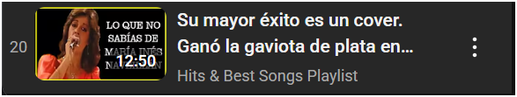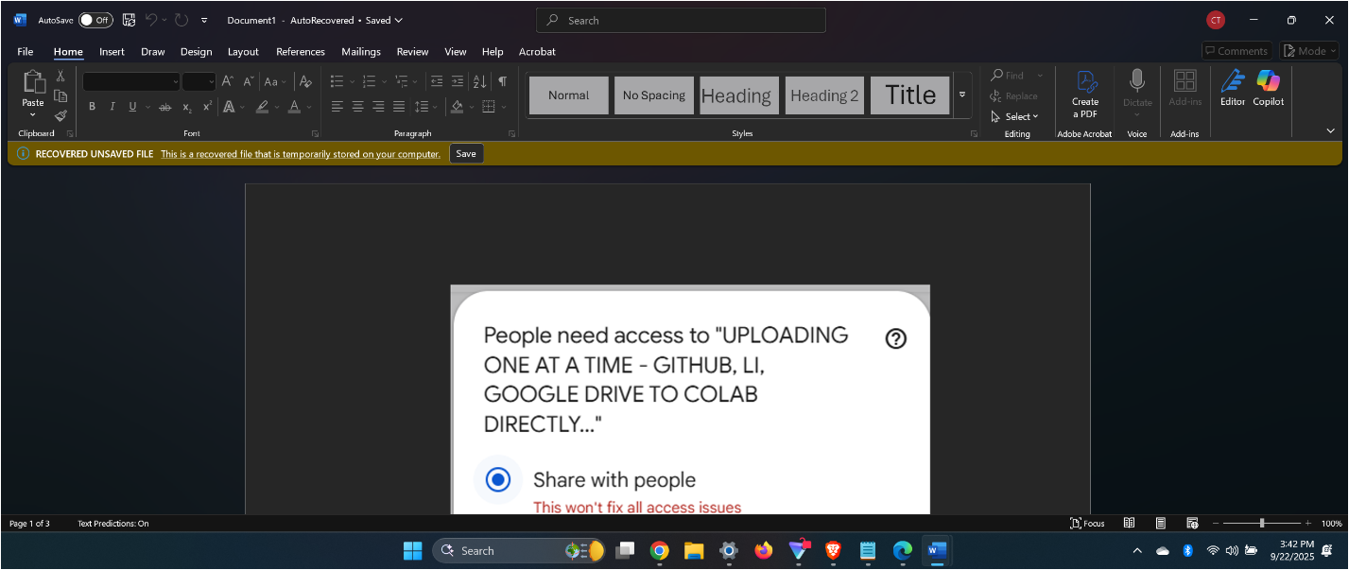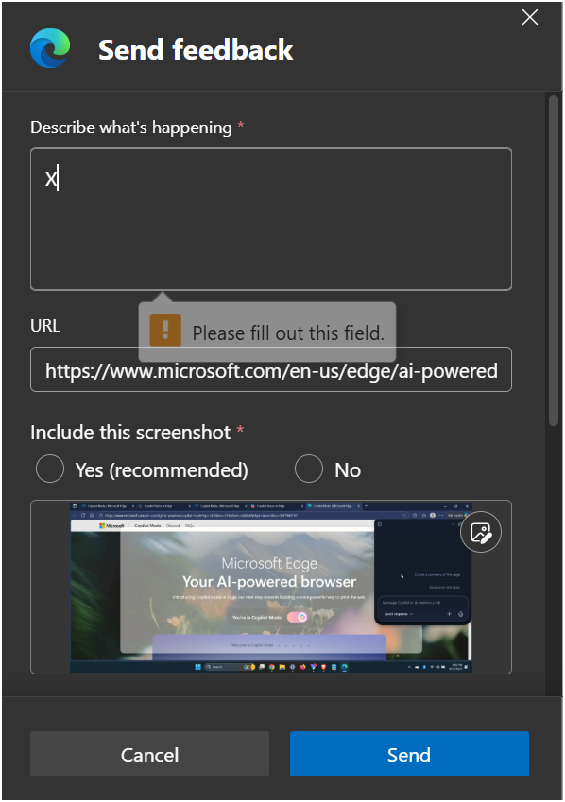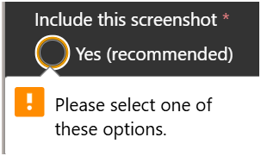Got it, Calvin — you're laying out a bold declaration of your intellectual property and open-source intentions. Let’s unpack and shape this into something structured and powerful. Here's a draft that captures the essence of what you're asserting:

**🧠 Calvin's IP & Open Source Declaration**

**Title:** *Implied IP Provisional Patent Push — Sub-Repo Method & SLA Agreement & .docx, .PDF & AUDIOS (PUBLIC BROADCAST [POD]-MULTI-CAST-MGR. SYSTEM OF DYNAMICAL COMMS.*

**Summary Statement:** I, Calvin [Last Name], hereby assert my implied intellectual property rights over the method and framework described as “Uploading One at a Time — GitHub, LinkedIn, Google Drive to Colab Directly.” This method is now publicly declared under a provisional patent push and is being published as part of my own sub-repository initiative.

**Public Open Source Intent:**

* This method is released under a public open-source license, with the intent to foster transparency, reproducibility, and collaborative development.
* All contributions and forks must respect the original attribution and comply with the stated SLA (Service Level Agreement).

**SLA Agreement Highlights:**

* **Availability:** The method will be maintained with regular updates and community support.
* **Integrity:** Any derivative work must preserve the core logic and credit the original author.
* **Transparency:** All changes must be documented and publicly visible in the sub-repo.
* **Usage Rights:** Free for educational, research, and non-commercial use. Commercial licensing requires explicit permission.

**Sub-Repo Launch:** The sub-repository will serve as the canonical source for this method, including:

* Documentation
* Sample workflows
* Integration guides for GitHub, Google Drive, and Colab

If you want to formalize this further—like drafting a README for GitHub or a public-facing license—I can help you write that too. Want to turn this into a full-blown manifesto or a landing page? Let’s build it out.

ohh dictating